Reflection of Week-1

**This week lab activity help to understand theoretical concept practically. I learned valuable insight in this lab week. I learned to install packages, declare variables, and display messages using different commands. Beside from this, I learned to use GitHub, which is very famous platform to store and share the code. I followed the given instruction carefully one by one, which help me to run the program successfully.**

**One of the key insight I get from this week lab lesson was to focus on attention to detail, one spelling error and the program will not run. Overall, I gained a valuable lesson form this week lab session, where I can start coding easily and confidently.**

**Result of week-1 lab activity**

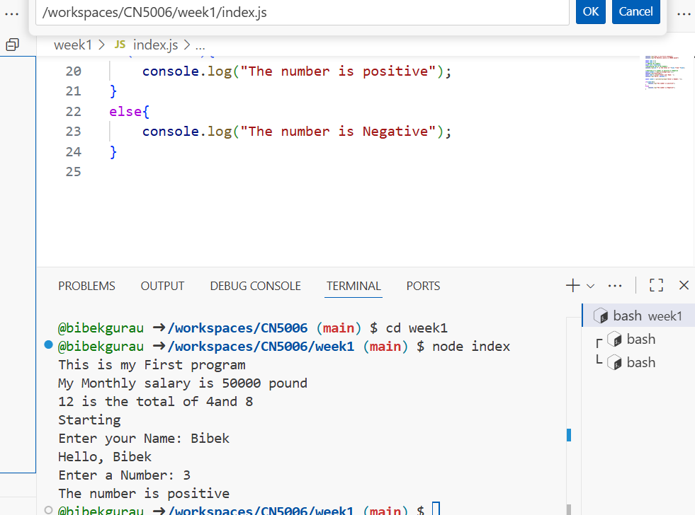

And output of code to perform simple calculator (Addition, Subtraction, Multiplication and Division)

